Wing Commander (SNES)

In order to talk to another pilot, you must:

1. Hold select and press R, this will cycle your right screen through various menus and data screens.
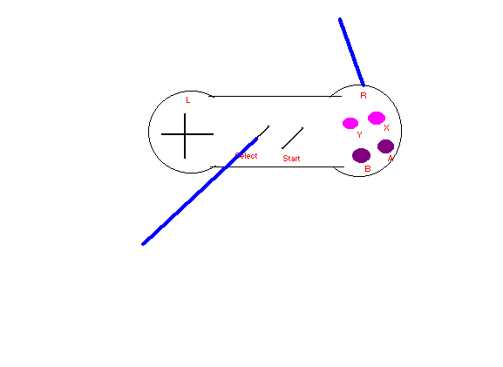
2. Once you've found the screen that says "Nav Vid" at the top -- stop. Hold select and press X to scroll down the different names or quotes.
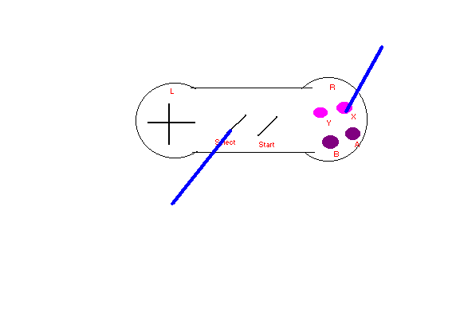
3. Choose a pilot by pressing the X button, without holding select.
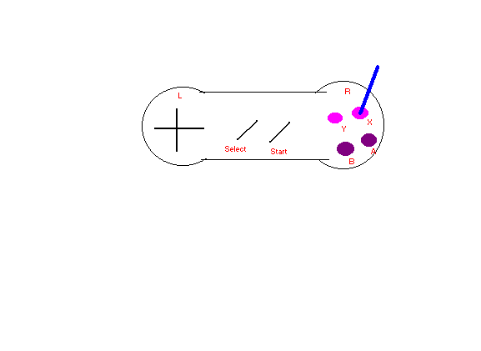

4. Choose your next quote by, once again, holding select and pressing "X."
5. And finally, once you've found what you want to say, press "X" and let your fellow pilot chatter with you, obey you, turn you down, or, possibly, blow you away!
Happy Flying,
*******@Earth.TCS.Navnews
June 17th, 1999

